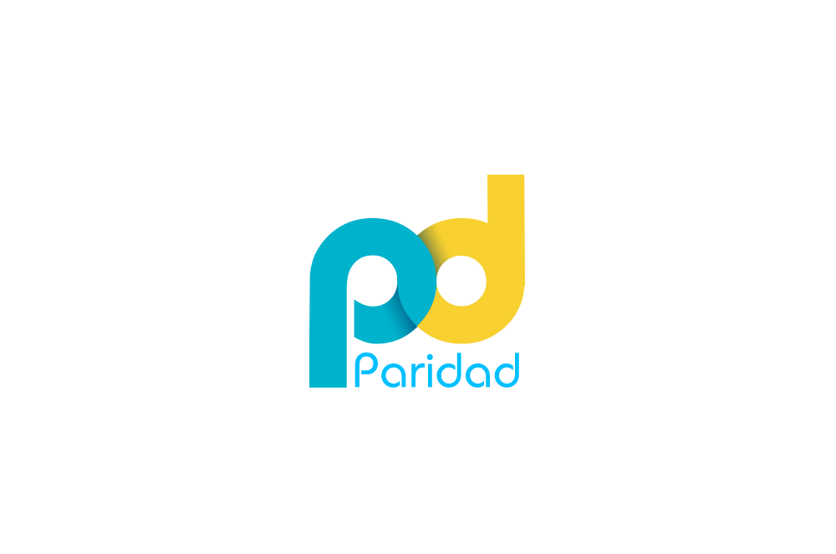

**Paridad Education Consulting**

5315 Clark Street, # 229

Chicago, IL 60640

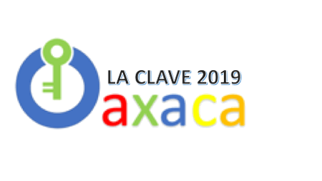

**Chicago, IL (July 15, 2019) &**

**Chicago, IL (July 15, 2019 & Oaxaca, Mexico (July 18-26, 2019)**

The LA CLAVE 2019 Institute is designed for both teachers and administrators to understand and authentically incorporate **language** and **culture**curricular components into units that build on the linguistic, cultural and cognitive assets of multicultural learners, through a series of **social justice focused** field experiences in Oaxaca, Mexico.

**Context, Program, and Goals**

***Clave* is** a Spanish word whose multiple meanings accurately represent the multifaceted scope of the curricular work of this institute. The phrase *la* *clave or un(a) clave* can signify, *“a code”,* *“a key”,* *“a password”*, *“a keyboard”*, *“a keystone”,* in addition to the *bass clef* on a piano keyboard. As it is the goal of this curriculum development institute to bring together the ideas of **art** (*musical notation*) and **language** (*codes*, as in “*code-switching*”), and to **culture** (as a *keystone* and a *means of accessing and understanding* a people), it is easy to see the appropriateness of this acronym and its multiple connotations in Spanish.

LA CLAVE de Oaxaca 2019 proposes a three-part modular program (*see Institute description section below*) with parallel and interactive pathways for both teacher practitioners and administrators. Through this modular approach, we seek to maximize the range of educators that will benefit from this rich, transformative experience. This modular approach also allows us to create post-institute curricular and instructional supports and coaching opportunities for the participating district teams.

**Curriculum for the Emergent Bilingual Learner**

An additional goal of this institute is to examine the instructional needs of emergent bilinguals. The needs of these students, who function both in Spanish and English, are often not adequately met, even in quality dual language programs. When dual language programs adhere to language separation and strict allocation, they create language restrictive environments, which Jim Cummins referred to as “The Two Solitudes”, where emergent bilinguals do not get to use the full complement of their linguistic strengths. The LA CLAVE Institute seeks to break down the curricular barriers between languages to address and support the biliterate and bicultural identity of these emergent bilingual learners.

**THREE MODULE INSTITUTE AND PROFESSIONAL DEVELOPMENT PROGRAM:**

**MODULE 1-Bilingual Curriculum Planning Sessions (John F. Hilliard & Cristina Sánchez-López):**

This one day, Pre-Institute Curriculum Planning session is designed for individual educators, as well as teams of educators, engaged in the process of refining or creating bilingual units of study. Participants will be given an overview of the essential language and culture components (see Mirrored Framework document), at both the unit and lesson level, for the creation of an integrative bilingual curriculum with an arts and social justice focus.

**Module 1-Administrator Strand (Margo Gottlieb):**

Administrators will review and refine a checklist based upon the for the essential language and culture features of the Mirrored Framework for purposes supporting teachers in classroom application of the multilingual/multicultural units. This checklist will also serve as reference document for their field experiences and discussions during Module 2 in Oaxaca.

**MODULE 2-Oaxaca Content-Collection Field Experiences (Paridad Associates, Artists & Culture Experts):**

The LA CLAVE 2019 Oaxaca field experiences provide 12, ½ day targeted opportunities for participants to collect substantive content related to five themes (see attached tentative itinerary). These themes are organized across content areas and are aligned with content-based standards. The focus for the participants during their field work is to participate in in-depth discussions with experts and build repositories of audio, video, text and graphic content that will serve as the building blocks of their units. Participants will identify their theme of interest during Model 1. During the field experiences the participants will interact with experts across the targeted content and themes. Some of the content will include archeology, indigenous cultures, gastronomy, flora, fauna and biological diversity, folk art & fine art, architecture, colonial history, social action and justice, etc.

***Oaxaca Field Experience Products:***

Participants will be presented with **two Oaxaca-based art projects** that will challenge their ideas about text and the sequencing of time. These projects will not only allow participants to experience new techniques and graphic art forms but also to understand the importance of incorporating more visual information into their own instruction (for teachers) and presentation of planning information (for administrators) that are part of the heritage of their students.

**Codice (Codex) Project & Calendario Projects**

These projects will allow participants to explore traditional, culturally relevant text forms steeped in indigenous cultures of Oaxaca known as the codice (codex) and the calendario (calendar). Two well-known graphic/print artists from Oaxaca, Maestro Jesus Gerardo de la Barrera, and Maestro Fortino Javier Vásquez Arellano will first present the history and context of each of these graphic text forms and give examples of their own work using the forms. Paridad Associates will also lead discussions on the relevance of these two culturally-based forms to both classroom instruction and effective ways of communication within a school setting.

Administrators will be encouraged to select the *calendario* form to explore ways of transmitting timeline and planning information to various stakeholders in their schools in a culturally relevant graphic way.

Participants will then be asked to gather their own graphic information (pictures, drawings, icons, letters, etc.) over the course of the field experiences to incorporate into the hands-on creation of their individual projects. Below are examples of both the traditional forms and projects by La Clave participants based on these forms.

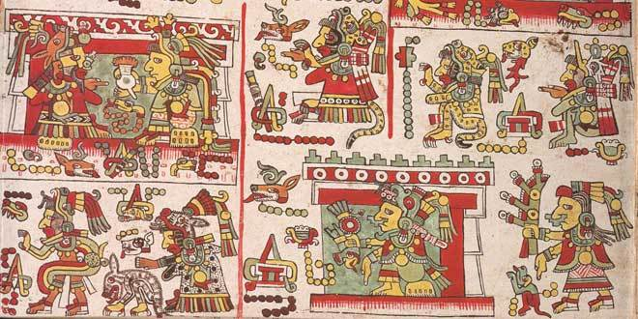

Traditional Mixtec Codice (Codex)

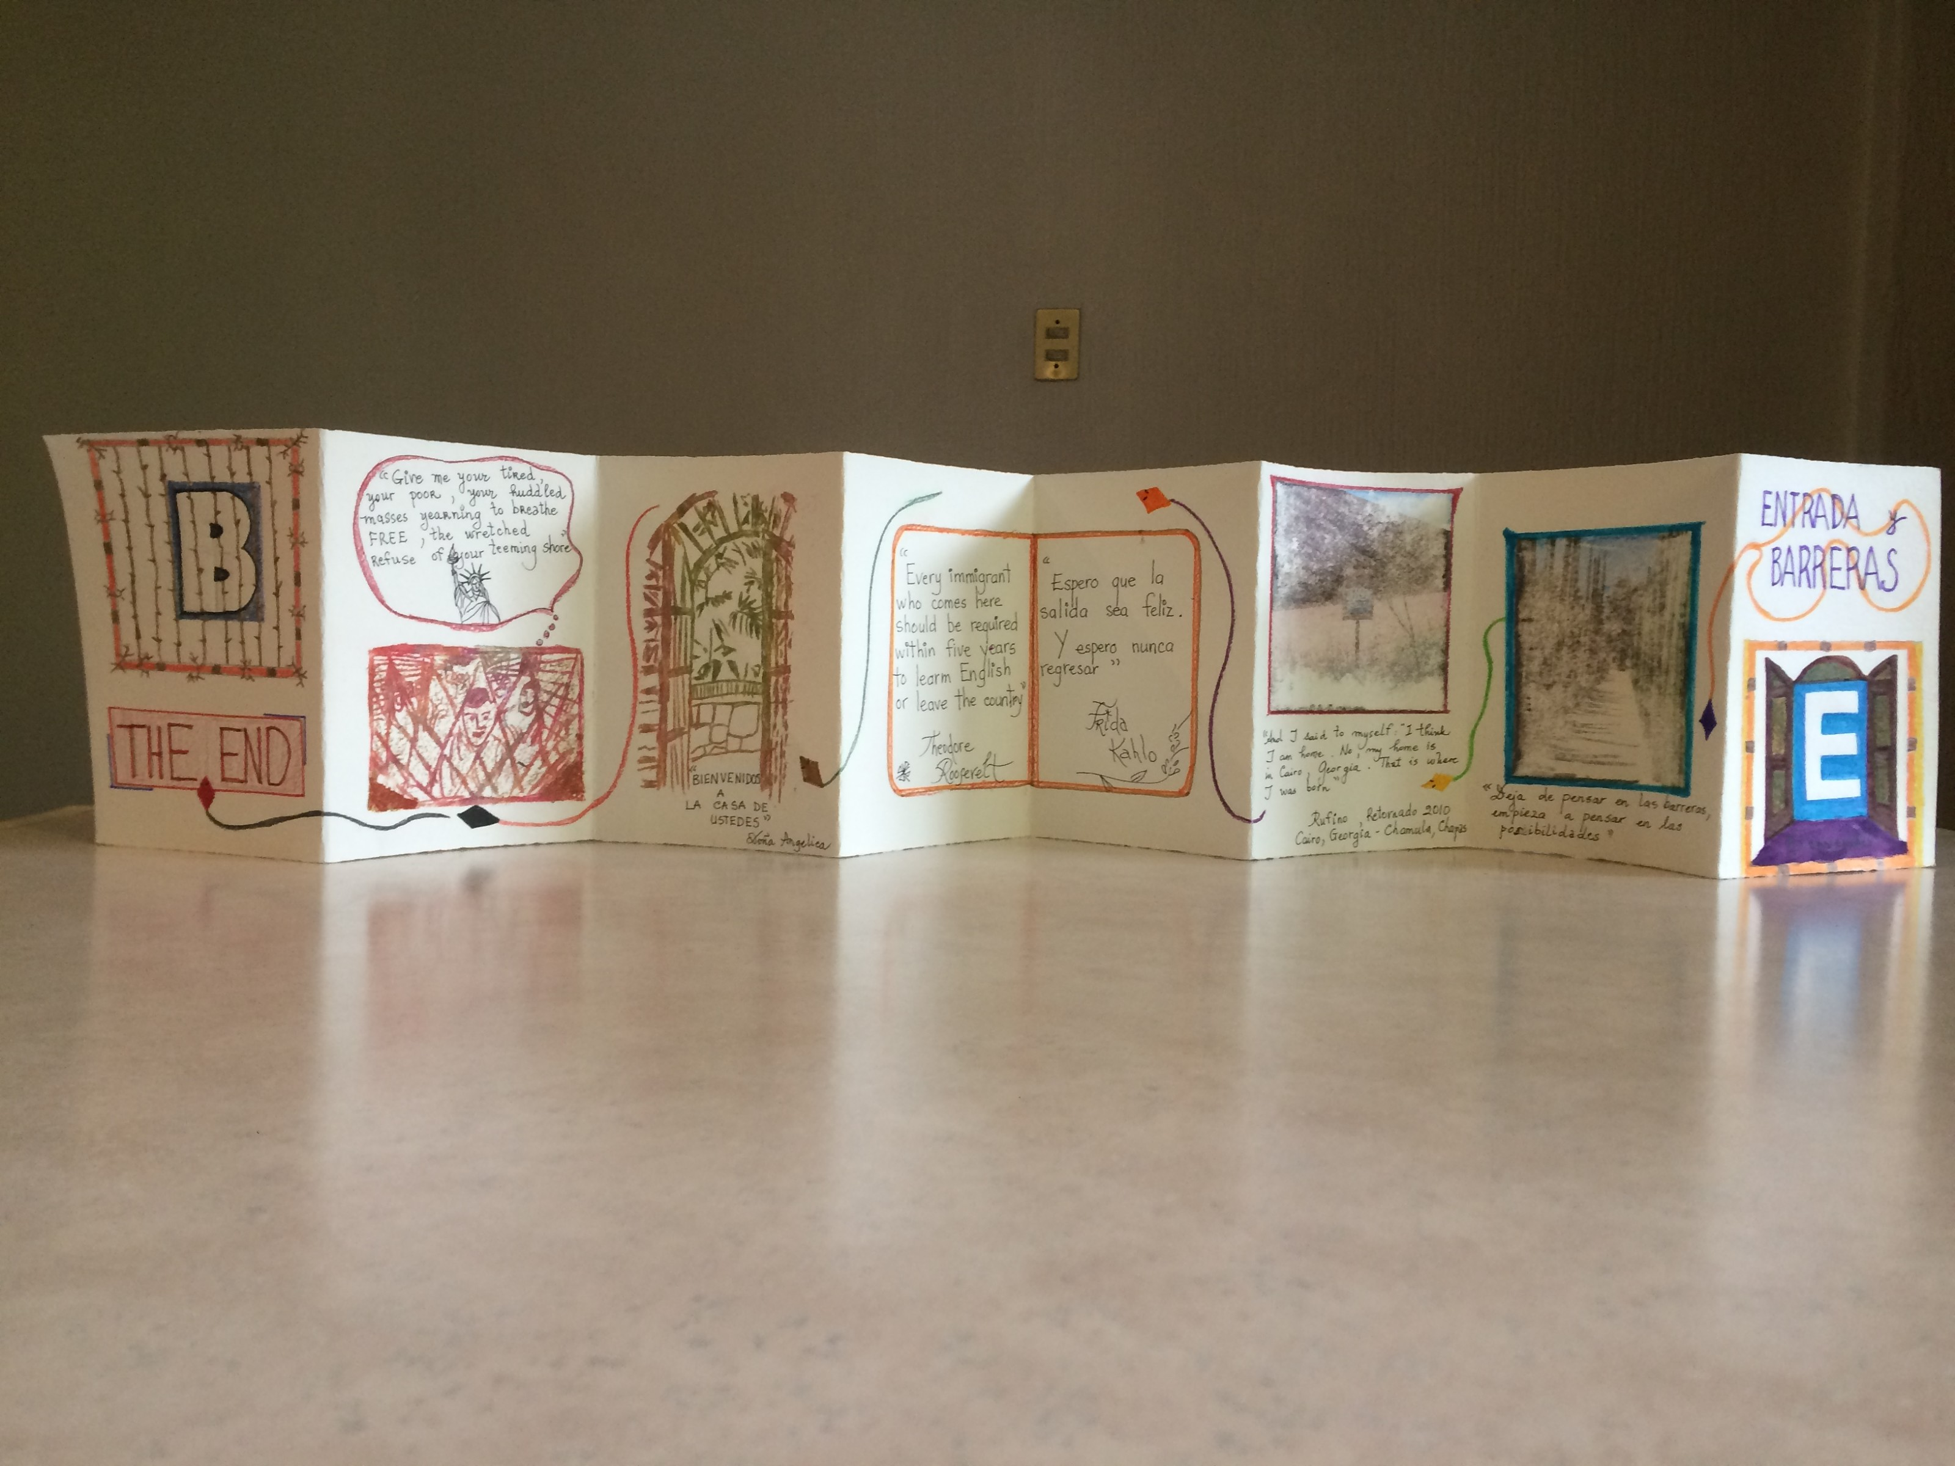

Codex project created by La Clave participant, 2018

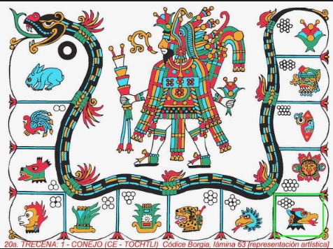

Example of Candelario (Calendar) Form

**MODULE 3: Implementation, Coaching, Evaluation and Dissemination of Curricular Units:** As part of the final module, districts sending curriculum development teams and administrators will also be able to schedule post-Oaxaca in-district services that will allow the teams to receive targeted feedback on their curricular units and lessons and administrator to receive technical assistance to support the delivery of the units.

Administrators will also be able to work with Paridad Associates in developing strategies for disseminating information about the curricular projects to a variety of stakeholders.

We were humbled and honored by the extraordinary feedback we received from our 2018 La Clave Institute,

*“One of the best P.D. experiences I have ever attended. I thank Paridad for this extraordinary experience.”*

*And our goal is to provide the 2019 cohort with and even richer and more impactful personal and professional experience. We hope that you will be able to join us on this transformative journey.*

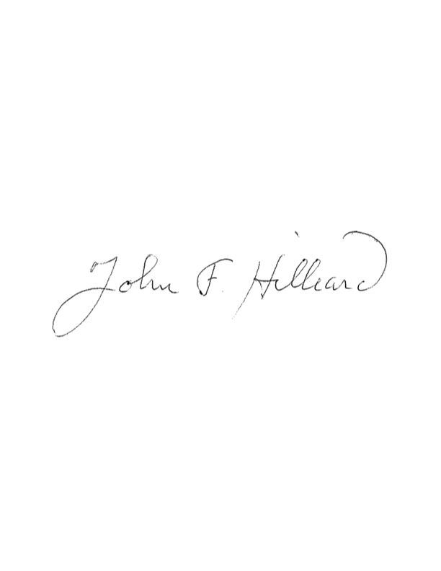

John F. Hilliard

President & Founder

Paridad Education Consulting